 ICD-900Series Card Dispenser

Features
·Dual motors, industrial bearings to ensure efficient Card dispensation Anti-double card dispensation, without card reclaiming function
·Optical isolation,Anti-Hot Plug,industrial grade chip ensure the high reliability of the circuit
·Stainless steel components、Special rubber wheel To ensure long-term operation and high life
·Full features and compact structure, east to maintenance.

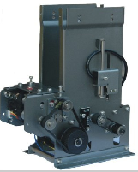
Application
·Entrance tickets issued
·Telecom Self Vending System
·Game card distribution system
·Parking charge system

m

Technical parameters
Supply voltage: DC24V 10%Current
Quiescent Current: less than100mA
Working current: less than500mA
Fault-free: card dispensation quantity can up to 1 million pieces
Card feeding out speed: maxinum can up to 0.5 second/piece
Maximum capacity (without overlapping)
130mm (170pieces0.76mmcard thickness), Maximum capacity can be expanded to 500.
Size: 76-86mm (length) 53-56mm (width) 0.2-2.0mm (thickness)
Cards capacity: 5-100pcs (adjustable)
Interface: TTL/RS232/RS485
Ambient temperature and humidity
Working -20-70degree0-90%RH storage30-80degree0-95%RH
Weight: 1.5Kg
Support multiple machine communication quantity: up to 32 joint
Materials: All kinds of PVC cards and paper cards
Dimension: 161.5*102*212MM
Operation condition: in cabinet

ICD-1500RF Series Card Dispenser

Application:
Toll system of car parks
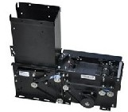
Access control system
Smart parking lot

2. Features
- Waterproof, dustproof and physical protection
- card stack holder（the card containers）is removable
- Compact size
- Postposition of the card reclaiming bin
- Unique way of reclaiming
- Slit is easy to adjust
- Optimized the PCB design
- Feature setting is flexible

Technical data

- Rating Voltage: 24VDC (MAX current 2A, static current 0.1A)
- Operating temperature: -15℃～70℃
- Operating relative humidity: 20%-90%
- Card Material: all kinds of paper cards and PVC / Mylar cards
- Card demension:L( 76mm～86mm)* W(53mm-56mm)*H( 0.2mm-2.0mm)
- Interface
- TTL, RS232, RS485 level control
- Used condition: installed in bin
- N. W: 2.5Kg
- Card Dispense Speed: about 0.5s

Applicative Card Jaws
Mode K2 ：installed on card dispenser
Mode K4 ：installed on poll box

ICC-1105 Series Card Collector

Application:
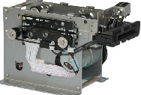
Toll system of car parks
Access control system

Features
- High reliability
- Integration design, function is complete
- Miniaturization
- High efficiency

Technical data:

- Rating Voltage: 24VDC (MAX current 2A, static current 0.1A)
- Operating temperature: -15℃～70℃
- Operating relative humidity: 20%-90%
- Card Material: all kinds of paper cards and PVC / Mylar cards
- Card dimensional:( 76mm～86mm)* W(53mm-56mm)*H( 0.2mm-2.0mm)
- Interface
- TTL/COM mode
- Used condition: installed in bin
- N. W: 0.8Kg
- Card Dispense Speed: about 0.5s

Applicative Card Jaws
Mode K2 ：installed on card collector

ICC-1115 Series Card Collector

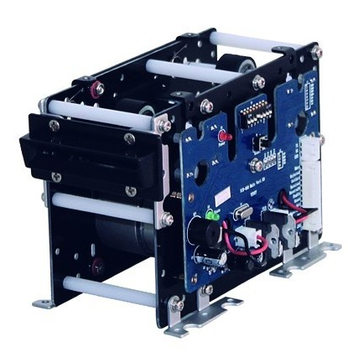
Application:
Toll system of car parks
Access control system

Specification
- Prevent accept the second card when the first card still in the channels
- Use plastic as body casing and will minimize effect to any contactless reader.
- Industrial design, good resistance to abrasion and corrosion, fit for high and low temperature environments.
- Directly connect to the inductance signal to achievement card s collection when car is coming.
- Provide RS232/RS485 or I / O voltage two control interfaces
- Die-wide production ensure the products, quality and consistency

Technical data:

- Operating Voltage: 24VDC (MAX current 2A, static current 0.1A)
- Operating temperature: -20℃ to 80℃
- Operating relative humidity: 30%-90%
- Used condition: installed in bin
- Card Material: all kinds of paper cards and PVC / Mylar cards
- N. W: 0.7Kg
- Card collection speed: about 1.0s

Applicative Card Jaws
Mode K5 ：installed on card collector

ICC-300 Series card collector

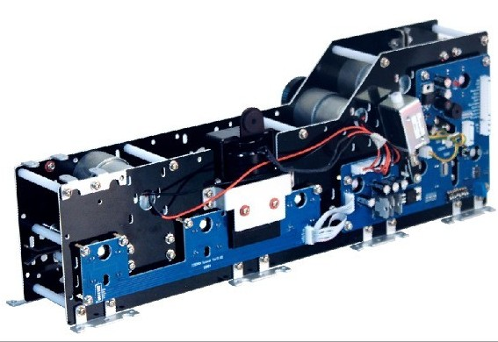
ICR-300 Series card collector makes of the high-intensity and resist surface corrosion materials. It is designed and produced on industrial standard. The core is especially design for access barriers system. It is applicable to automatic ticket checking system in tourist attractions and exhibition venues or others auto ticket checking system.
There are two important components which are straight mechanism and turning mechanism, and customers can be any combination to meet different needs.

Specification
- Industrial design fit for high and low temperature environments.
- Can install bar code scanner, RF reader or other tickets checking device
- Slotting functions with paper tickets, can be set 4 different drilling locations
- Aclinic tickets in, up (90°) and aclinic tickets out (optional).
- Automatically collect tickets and over 3 seconds automatically quit tickets
- Collect tickets continuously: the second ticket can be collected when the first ticket is waiting to be taken away
- Adjustable tickets collecting speed to fit for different bar code scanners and RF readers.
- LED for status indicator and buzzer alarm for failure
- Technical data:
- Card Material: paper tickets, RF cards
- Slotting speed: about 0.6s
- Collecting speed: about 0.5s (adjustable)
- Operating Voltage: DC 24V/5A
- Operating temperature: -20℃ to 80℃
- Operating relative humidity: 30%-90%
- Used condition: installed in bin

Applicative Card Jaws
- Mode K2：installed on card collector （One card straight mechanism can be used as card collector）

IMCD-350 Motor hybrid Card Reader and Writer
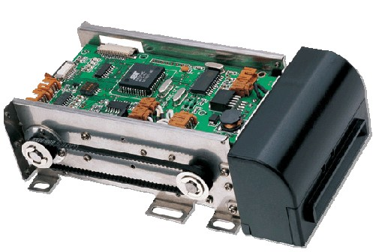

Application:
- ATM
- Self-service terminal
- Electronic purse
- Vending machine
- POS
- Adding value machine
- Multi-media information kiosk

Features:
- EMV certified
- Magnetic/IC/RFID card read/write
- Lo-Co & Hi-Co encoding options
- SAM slot option
- Electric& security shutter options
- Insert& eject from front/rear side
- ROHS-compliant, durable, robust

Technical data:
Card standard | IC Card :ISO7816-2
Card standard | Magnetic Card:ISO7810 ID-1,7811/1,2,3,4,5 and 6
Card standard | RFID Card:ISO14443-A
Communication | RS-232/ USB
Life | Magnetic head: 1,000,000 cycles min
Life | Contact pin: 500,000 cycles min
Life | Gearing: 1,000,000 cycles min
Power supply | DC 24V+/-10%
Environmental requirement | Operation:0~50oC/0~90%RH(No condensing)
Environmental requirement | Storage:-10~75oC/0~90%RH(No condensing)
Weight | Approx.2kg

